****GALGOTIAS UNIVERSITY

Plot No.2, Sector -17 A, Yamuna Expressway,

Greater Noida, Gautam Buddh Nagar, U.P., India

SCHOOL OF COMPUTING SCIENCE & ENGINEERING

Embedded Technology and IOT

Lab Report

On

“Internet of Things”

Course Name: Embedded Technology and IOT

Course Code: [BEE01T1004](https://lms.galgotiasuniversity.edu.in/course/view.php?id=63727)

School: SCSE

Program: B.Tech

Year: 1st Semester: 2

Session: 2021-2022

|  |  |
| --- | --- |
| Submitted By: | Submitted To: |
| Abhinav Kumar Choudhary(21SCSE1011615) | Dr. USHA CHAUHAN |

INTRODUCTION

The Internet of things refers to a type of network to connect anything with the Internet based on stipulated protocols

through information sensing equipments to conduct information exchange and communications in order to achieve

smart recognitions, positioning, tracing, monitoring, and administration. The IOT concept was coined by a member of the Radio Frequency Identification (RFID) development community in 1999, and it has recently become more relevant to the practical

world largely because of the growth of mobile devices,

embedded and ubiquitous communication, cloud computing

and data analytics.

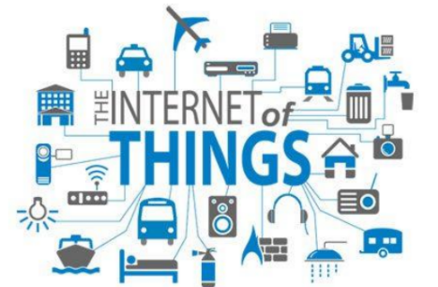

Internet of Things is a new revolution of the Internet. Objects

make themselves recognizable and they obtain intelligence by

making or enabling context related decisions thanks to the fact

that they can communicate information about themselves. They

can access information that has been aggregated by other

things, or they can be components of complex services.

Characteristics :

The fundamental characteristics of the IoT are as follows :

* Interconnectivity: With regard to the IoT, anything can be

interconnected with the global information and communication

infrastructure.

* Things-related services: The IoT is capable of providing

thing-related services within the constraints of things, such as

privacy protection and semantic consistency between physical

things and their associated virtual things. In order to provide

thing-related services within the constraints of things, both the

technologies in physical world and information world will

change.

* Heterogeneity: The devices in the IoT are heterogeneous as

based on different hardware platforms and networks. They can

interact with other devices or service platforms through

different networks.

* Dynamic changes: The state of devices change dynamically,

e.g., sleeping and waking up, connected and/or disconnected as

well as the context of devices including location and speed.

Moreover, the number of devices can change dynamically.

* Enormous scale: The number of devices that need to be

managed and that communicate with each other will be at least

an order of magnitude larger than the devices connected to the

current Internet.

Even more critical will be the management of the data

generated and their interpretation for application purposes.

This relates to semantics of data, as well as efficient data

handling.

* Safety: As we gain benefits from the IoT, we must not forget

about safety. As both the creators and recipients of the IoT, we

must design for safety. This includes the safety of our personal

data and the safety of our physical well-being. Securing the

endpoints, the networks, and the data moving across all of it

means creating a security paradigm that will scale.

* Connectivity: Connectivity enables network accessibility and

compatibility. Accessibility is getting on a network while

compatibility provides the common ability to consume and

produce data .

